# Technical Solution

Check for temp work arounds like those in SudokuGrid.generate_new_puzzle

And for non-formal comments

Not included: Sudoku grid, options menu, give hint, anything SQL related, or save

## Server

### Place cell

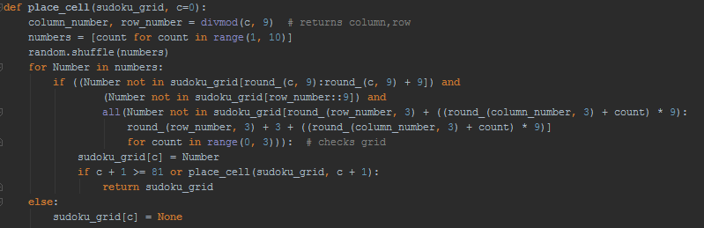

This code generates the completed Sudoku grid recursively by first shuffling a list of numbers 1 to 9. Then it iterates through the list, and it will place the first valid number it iterates to. If there is no number which can be placed onto the tile, it will backtrack and continue from where it left off on a previous tile

### Input handle

This is the main loop that my code loops through, every tick it will get the most recent input from the user, if it is a mouse click it will run the handle_click function below, if the user pressed a numerical button then it will try to edit the tile’s value, if the tile cannot be edited i.e. the edit procedure is not defined then it will not edit the tile.

### Handle click

This function takes the arguments: left_click – a Boolean statement to determine wheter the left button was pressed and mouse_pos – the postion of the mouse on the screen. The code goes through all the buttons on the current screen and checks if any of them have been clicked, if the game is currently in the main menu it will remove the tile highlighting in the Sudoku grid. If the tile has been clicked on it will store it for use in editing a tile’s value. Finally it will run the function of the object with arguments if it has them.

### Rotation

This takes a 1D array that represents a 2d square (with length being the length of one of the sides) and rotates it through 90o, 180o, 270o it does this by using a Cartesian representation of matrix rotation.

$$\left({\cos{θ}, -\sin{θ} \atop \sin{θ},\cos{θ}}\right)\left({x \atop y}\right)= \left({x\cos{θ}-y\sin{θ} \atop x\sin{θ}+y\cos{θ}}\right)$$

This shows the matrix rotation of a 2d vector through $θ$, which is the equation I have used (defined in rotate_to)

In the turn function it takes the rotate_to function, the array and the length of one of the sides. It firstly makes a blank list of the same length of the array, and then iterates through the array keeping track of its index, next, the index is converted into a set of co-ordinates, which are then transformedby the rotate_to function then the new_index is made and the value is written to that location in the new array.

